**Name-Ujjawal Mandhani**

**Batch-F6**

**Enroll No.-9918103237**

**OSS Lab – 7**

**Question 1:**From given data set, print first and last five rows.

**import pandas as pd**

**data = pd.read_csv("data.csv")**

**def Head_and_tail():**

**print("Head\n")**

**print(data.head())**

**print("Tail")**

**print(data.tail())**

**Head_and_tail()**

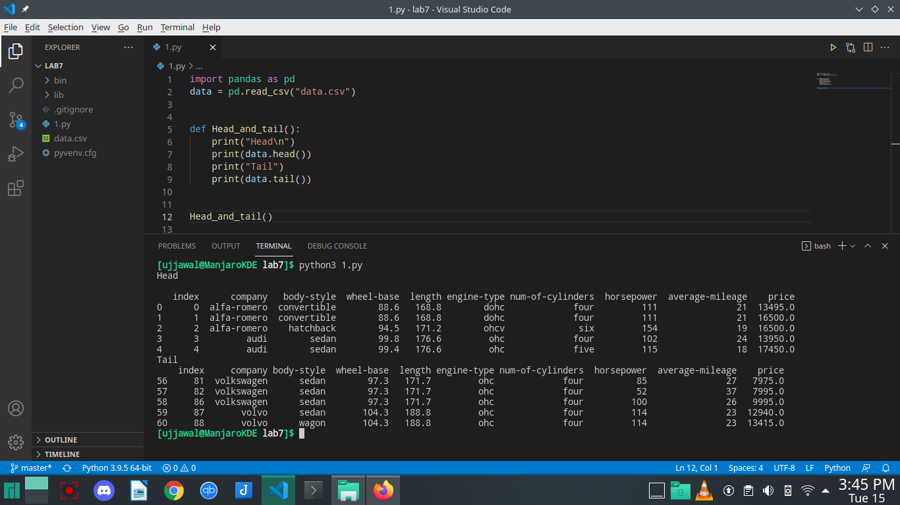

**Question 2:**Replace all column values which contain ‘?’ and ‘n.a.’ with NaN. Update the CSV file.

**import pandas as pd**

**data = pd.read_csv("data.csv")**

**def replace_with_nan():**

**print("\nReplace all column values which contain ‘?’ and ‘n.a.’ with NaN")**

**data.replace(to_replace=["?", "na"], value="NaN")**

**data.to_csv("data.csv")**

**replace_with_nan()**

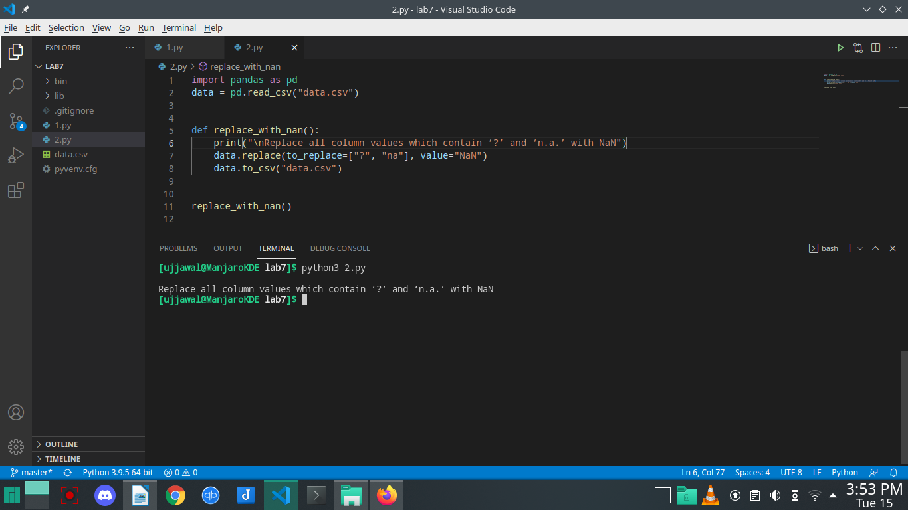

**Question 3:**Print All BMW Cars details.

**import pandas as pd**

**data = pd.read_csv("data.csv")**

**def all_bmw_cars():**

**print("\nAll BMW cars")**

**print(data.loc[data['company'] == 'volvo'])**

**all_bmw_cars()**

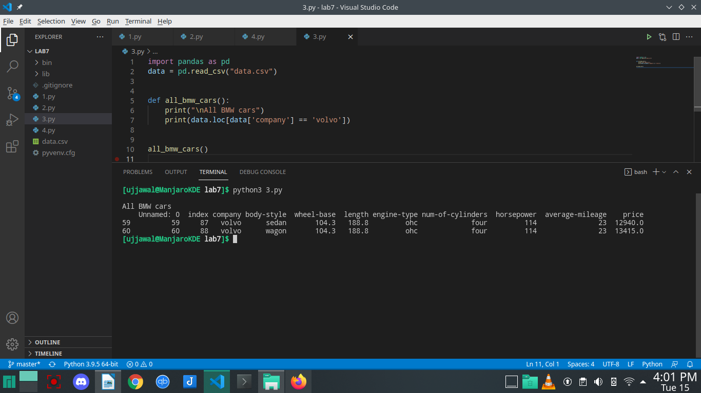

**Question 4:**Count total cars per company.

**import pandas as pd**

**data = pd.read_csv("data.csv")**

**def count_cars():**

**print("\ncount cars per company")**

**t = data.company.value_counts()**

**print(t)**

**count_cars()**

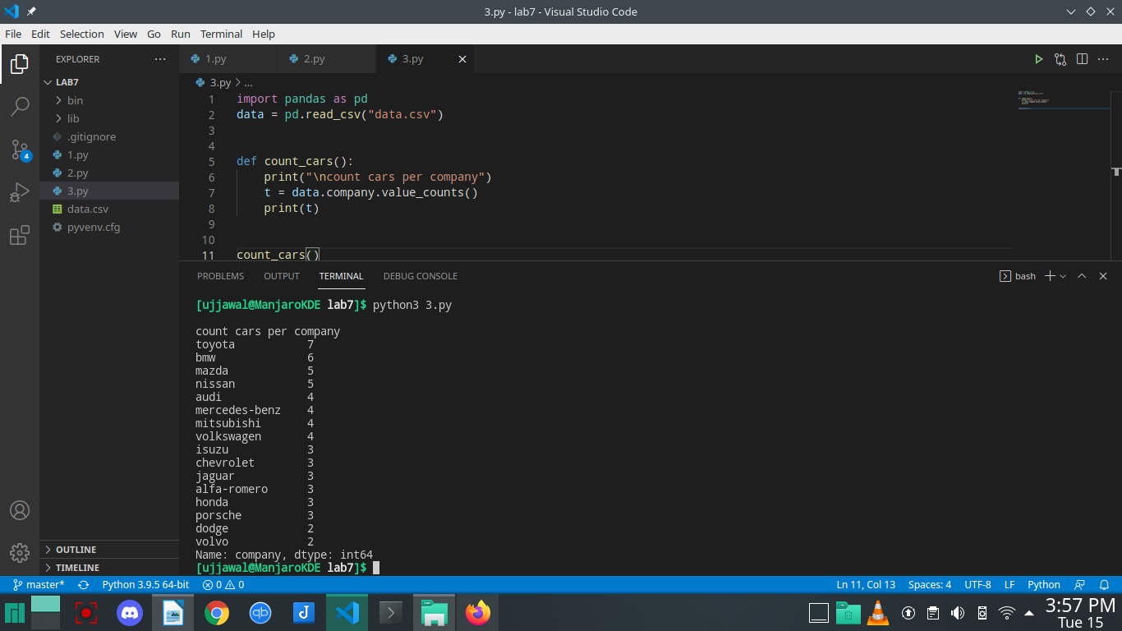

**Question 5:**Find each company’s Highest price car.

**def Highest_price_car():**

**print("\nHigest price car companies")**

**group1 = data.groupby('company')**

**max1 = group1.max()**

**max2 = max1.reset_index()**

**print(max2.filter(['company', 'price']))**

**Highest_price_car()**

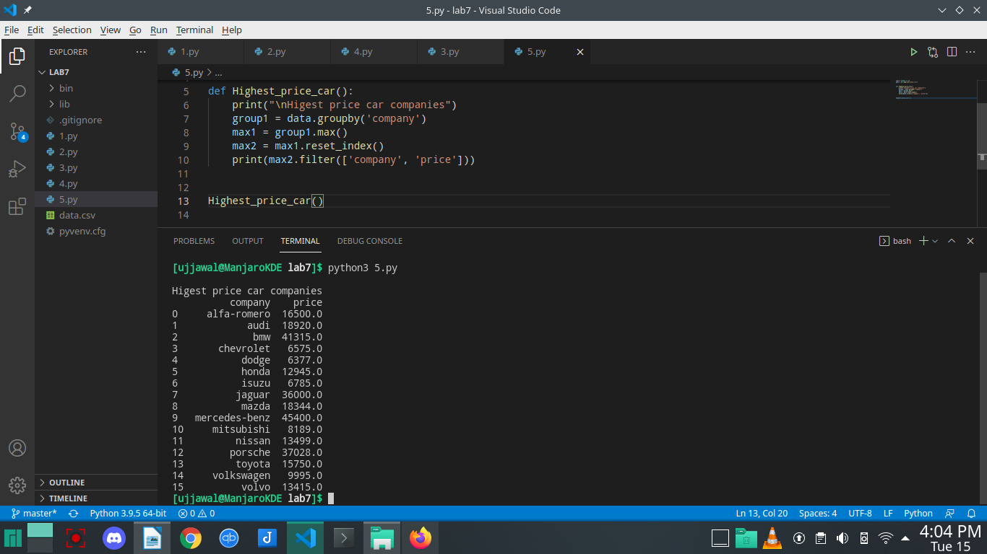

**Question 6:**Find the average mileage of each car making company.

**import pandas as pd**

**data = pd.read_csv("data.csv")**

**def average_milege():**

**print("\naverage milege of each car making company")**

**temp = data.groupby('company')**

**temp1 = temp['company', 'average-mileage'].mean()**

**print("\n")**

**print(temp1)**

**average_milege()**

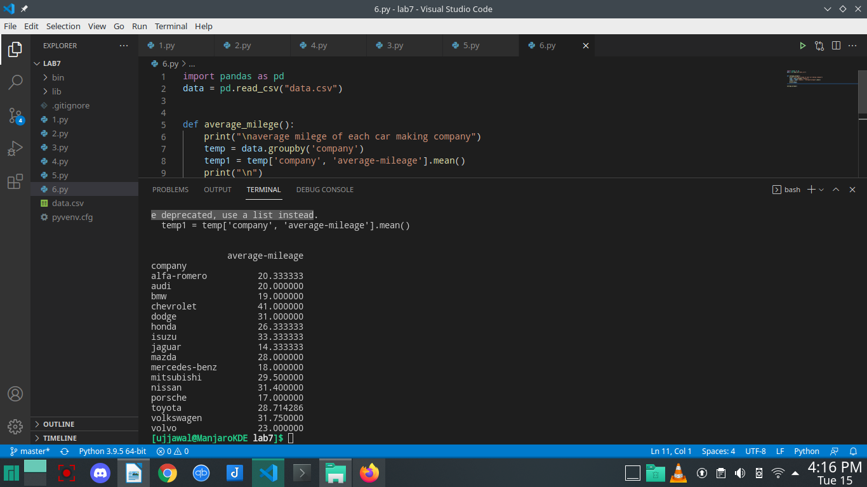

**Question 7:**Merge two data frames using the following condition: Create two data frames using the

following two Dicts, Merge two data frames, and append second data frame as a new

column to the first data frame.

* Car_Price = {'Company': ['Toyota', 'Honda', 'BMV', 'Audi'], 'Price': [23845, 17995, 135925, 71400]}
* Car_Horsepower = {'Company': ['Toyota', 'Honda', 'BMV', 'Audi'], 'horsepower': [141, 80, 182, 160]}

**import pandas as pd**

**data = pd.read_csv("data.csv")**

**def merging_df():**

**print("\nMerging two dataframes")**

**Price = {'Company': ['Toyota', 'Honda', 'BMV', 'Audi'],**

**'Price': [23845, 17995, 135925, 71400]}**

**carPriceDf = pd.DataFrame.from_dict(Price)**

**Horsepower = {'Company': ['Toyota', 'Honda', 'BMV',**

**'Audi'], 'horsepower': [141, 80, 182, 160]}**

**carsHorsepowerDf = pd.DataFrame.from_dict(Horsepower)**

**carsDf = pd.merge(carPriceDf, carsHorsepowerDf, on="Company")**

**print(carsDf)**

**merging_df()**

